TESTING ROOM RULES
IMPORTANT:
No cell phones or electronic devices! | 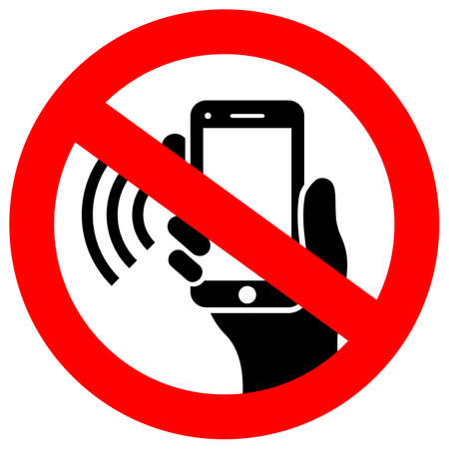

- Turn off your phone or device NOW.
- Put it away in your bag or turn it in to.
- Do not access it until testing is ended.

If you don’t follow these rules:
- Your phone or device may be taken away.
- Your test will not be scored/will be invalidated.
- You may be dismissed.

NEVADA STATE LAW

NO ELECTRONIC DEVICES
DO NOT ACCESS ELECTRONIC DEVICES DURING BREAKS

MUST SURRENDER ELECTRONIC DEVICES UPON ENTERING THE TESTING ROOM
THANK YOU

