|  |  |  |  |
| --- | --- | --- | --- |
| **LESSON PLAN PART I** | | | |
| **Lesson Title:** Organization of the JROTC  **Learning Outcome:** Identify the purpose and structure of the JROTC programs.  **Linked Course Outcome:** Analyze the heritage, organization, and tradition of service programs. | | | |
| **Learning Objectives:**  Students will learn the following knowledge, concepts, principles, and processes in this lesson:   * 1. Discuss the history of the nation’s Junior ROTC programs.   2. Explain the organization of JROTC programs.   3. Examine the lines of responsibility and authority in Junior ROTC programs. | | | |
| **Multiple Intelligences**  ☐Bodily/Kinesthetic  ☒Visual/Spatial  ☒Logical/Mathematical  ☒Verbal/Linguistic  ☐Musical/Rhythmical  ☐Naturalist  ☒Interpersonal  ☒Intrapersonal | **Revised Bloom’s Taxonomy**  ☐Remember  ☐Understand  ☐Apply  ☒ Analyze  ☐Evaluate  ☐Create | **Authentic Assessment**  ☐Observation  Checklist  ☒Quick Write  ☒Discussion  Questions  ☒Student  Activities  ☒Quizzes  ☒Test  ☒Project with  Rubric | **Materials:** Textbook, worksheets  **Resources:** Video clip, PowerPoint Presentation and Vocabulary File on Instructor Guide (IG) DVD, Computer with Internet Access, Classroom Performance System  **Student Preparation:**  Reading Assignment: Chapter 1, Lesson 1  Homework Assignment: Read Chapter 1, Lesson 2: The Military Uniform and Appearance Standards |
| **Linked *Mid-Continent Research for Education and Learning (McREL)* Standards**  Life Skills - Life Work  Standard 2. Uses various information sources, including those of a technical nature, to accomplish specific tasks  2. Follows basic linear paths in organizational charts  Standard 7. Displays reliability and a basic work ethic  1. Understands the concept of reliability (e.g., completing tasks on time; maintaining regular attendance; carrying out assigned tasks; being punctual)2. Understands ethical character traits as they relate to the workplace (e.g., honesty, integrity, compassion, justice)5. Develops good work habits (e.g., keeping an effective work station; organizing job responsibilities)6. Respects authority and is attentive to requests and preferences of supervisor  9. Understands the concept of loyalty to an organization  Standard 8. Operates effectively within organizations  1. Understands the organization’s basic goals and values  2. Understands the extent to which organizational values are compatible with personal values | | | |
| **Linked *National Educational Technology Standards for Students (NETS-S)***  3. Research and Information Fluency: Students apply digital tools to gather, evaluate, and use information. Students:  3.b. locate, organize, analyze, evaluate, synthesize, and ethically use information from a variety of sources and media.  3.c. evaluate and select information sources and digital tools based on the appropriateness to specific tasks.  3.d. process data and report results  4. Critical Thinking, Problem Solving, and Decision Making: Students use critical thinking skills to plan and conduct research, manage projects, solve problems, and make informed decisions using appropriate digital tools and resources. Students:  4.b. plan and manage activities to develop a solution or complete a project.  4.c. collect and analyze data to identify solutions and/or make informed decisions.  6. Technology Operations and Concepts: Students demonstrate a sound understanding of technology concepts, systems, and operations. Students:  6.a. understand and use technology systems. | | | |
| **Lesson Preparation**   * Review the entire lesson plan (recommend trial run through PowerPoint testing, Internet URLs, embedded video clip, and use of CPS); rubrics are located in the Appendix * Complete any pre-class preparation required and if applicable gather any materials necessary for the activities; make enough copies of all activities worksheets for the students * If possible, have computers with Internet connection available as applicable   **Lesson Presentation (Time: 90 minutes):**  ***Part IIA – Exploration*** (15 min): Begin the lesson with the CPS self-assessment and focusing questions. Present an overview of the chapter and this lesson. Have students complete the Quick Write reading/writing activity.  ***Part IIB – Engagement*** (60 min): Introduce each learning objective with supporting content from text and other resources as presented in slides; use any of the following learner-centered activities, with CPS if applicable, and review them for detailed instructions:   1. Individual/Partner Analysis Activity: History of JROTC Timeline 2. Individual Analysis Activity: JROTC Students Leading and Learning 3. Partner/Small Group Application Activity: JROTC Organizational Chart 4. Individual Technology Research Activity: Cadet Positions and Requirements   ***Part IIC – Wrap-up*** (15 min):Reinforce the material with the CPS review and transfer of learning questions to check the student’s comprehension of the material. If time permits, review and begin the Chapter 1 project.  **Evaluation:** Refer to the IG DVD for the lesson test files.  **Chapter Project-Based Learning and Assessment:** Assign the chapter project from the appendix. You may introduce the project in this lesson, and have students present their final projects by the conclusion of lesson six. The project focuses on critical thinking and problem solving, communication and collaboration, and creativity and innovation. Refer to the appendix for the full project description and instructions. | | | |

|  |
| --- |
| **PART II**  **PART IIA – EXPLORATION**  Estimated Time: 15 minutes |

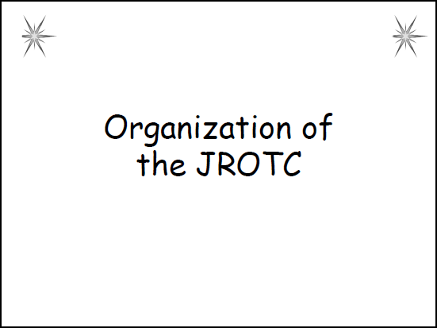

**ATTENTION**

Joining JROTC may be one of the best decisions you’ll make. The experiences and friends you make in JROTC will last a lifetime. But do you know what JROTC is all about? What will you gain from becoming a JROTC cadet?

**CPS Warm-Up Questions (1-2):**

*Note to teacher: Ask the following questions using CPS:*

1. 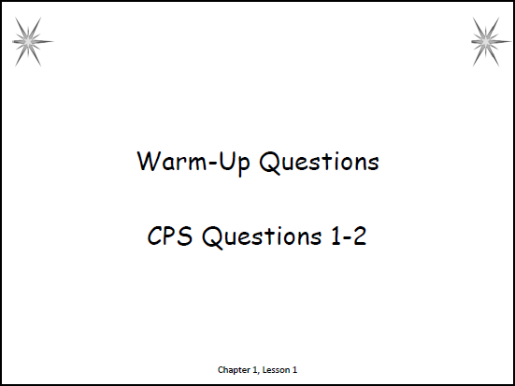How much information do you already know about this topic area?
   1. Expert – I have done a lot of learning in this area already.
   2. Above average – I have learned some information about this topic.
   3. Moderate – I know a little about this topic.
   4. Rookie – I am a blank slate…but ready to learn!
2. In _____, the ROTC Vitalization Act set the national criteria for schools to begin JROTC programs.
   1. 1960
   2. **1964** (p. 7)
   3. 1966
   4. 1970

**MOTIVATION**

There are many responsibilities and benefits of a JROTC cadet. Your experience in JROTC will enable you to become a better citizen and contribute to your community.

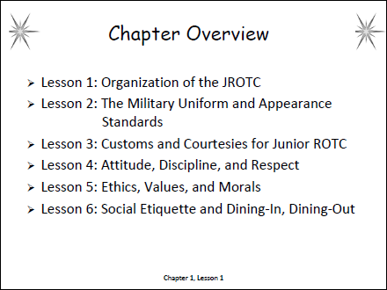**CHAPTER OVERVIEW**

Chapter 1 – Introduction to JROTC Programs includes six lessons that focus on the following:

Lesson 1: Organization of the JROTC

Lesson 2: The Military Uniform and Appearance

Standards

Lesson 3: Customs and Courtesies for Junior ROTC

Lesson 4: Attitude, Discipline, and Respect

Lesson 5: Ethics, Values, and Morals

Lesson 6: Social Etiquette and Dining-In, Dining-Out

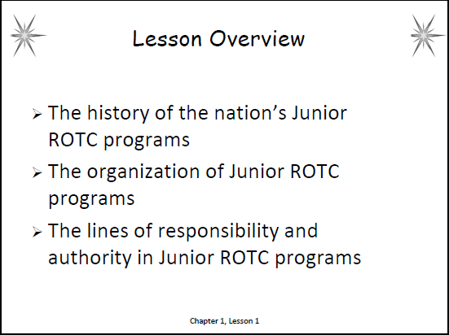**LESSON OVERVIEW**

In this lesson, you will learn about the organization of JROTC. We will cover:

1. The history of the nation’s Junior ROTC programs
2. The organization of Junior ROTC programs
3. The lines of responsibility and authority in Junior ROTC programs

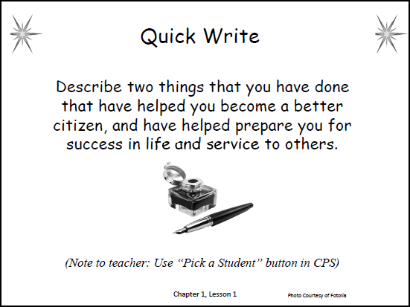**Quick Write with CPS**

*Note to teacher: Have the students read/review the opening story in the lesson. Then have them write a response to the Quick Write on a separate sheet of paper. Use “Pick a Student” button in CPS to select two or three students to share their answers.*

Describe two things that you have done that have helped you become a better citizen, and have helped prepare you for success in life and service to others.

|  |
| --- |
| **PART IIB – ENGAGEMENT**  Estimated Time: 60 minutes |

*Note to teacher: All student handouts and answer keys for the activities are following the “Checkpoints Answer Key” at the end of the lesson.*

1. 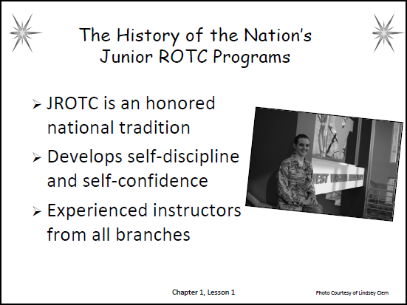**The History of the Nation’s Junior ROTC Programs**
   1. As a cadet in the Junior Reserve Officer Training Corps (JROTC), you are part of an honored national tradition
   2. Through JROTC, you will develop self-discipline and self-confidence
   3. Your instructors will be experienced retired officers or enlisted personnel of the Air Force, Army, Navy, Marine Corps, and Coast Guard
   4. 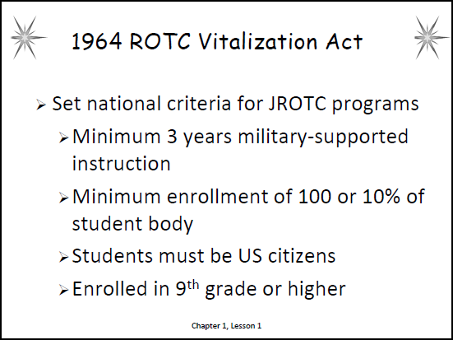The 1964 ROTC Vitalization Act set the national criteria for schools to begin JROTC programs
      1. The basic requirement was that schools applying for a JROTC program had to agree to provide at least three years of military-supported instruction
      2. For a program to be approved, the law required a minimum enrollment of 100 physically fit students, or 10 percent of the student body, whichever was less
      3. Since then, the military services have applied some of their own criteria to meet the needs of different high schools and their students
      4. Students must be US citizens and enrolled in the ninth grade or higher

________________________________________________

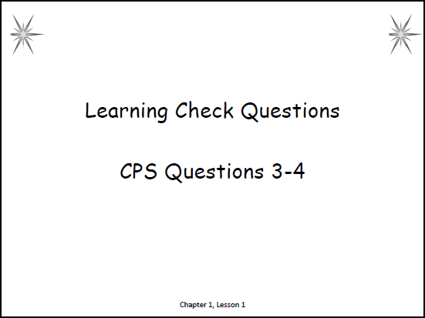**CPS Learning Check Questions (3 – 4)**

*Note to teacher: Ask the following questions using CPS.*

1. Which of the following will you develop through JROTC?
   1. Anxiety
   2. Security
   3. **Self-confidence** (p. 6)
   4. Self-control
2. Which of the following is a requirement to be a JROTC student?
3. Must be 18 years or older
4. **Must be a US Citizen** (p. 7)
5. Have a 3.0 GPA or higher
6. Enrolled in the 7th grade or higher

_______________________________________________

**Activity 1: History of the JROTC Timeline**

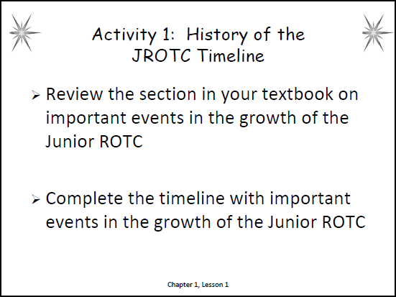

**Instructions for the teacher:**

1. This individual/partner analysis activity enables students to synthesize what they know about the history of the JROTC by creating a timeline of significant events.
2. Hand out copies of the student worksheet. Divide the class into partners if desired. For odd numbers, you may assign one group of three.
3. Review the directions on the worksheet with students.
4. Tell students to be prepared to share their answers with the class.
5. At the end of the activity, use CPS to select two or three students to share their answers.
6. Briefly review the correct answers.
7. 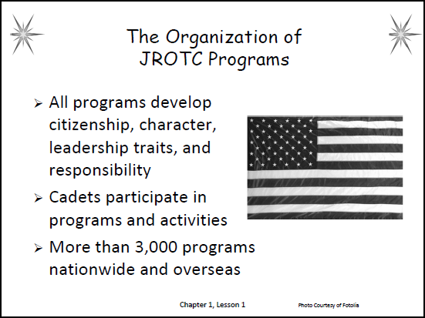**The Organization of Junior ROTC Programs**
8. All JROTC programs develop cadets’ citizenship, character, leadership traits, and responsibility
9. Cadets participate in the following:
   1. Community service, drill and ceremonies, traditional educational programs, uniform inspections, study of military history and customs, and fitness training
   2. More than 3,000 high schools nationwide and overseas offer Air Force, Army, Navy, Marine Corps, and Coast Guard JROTC classes
10. 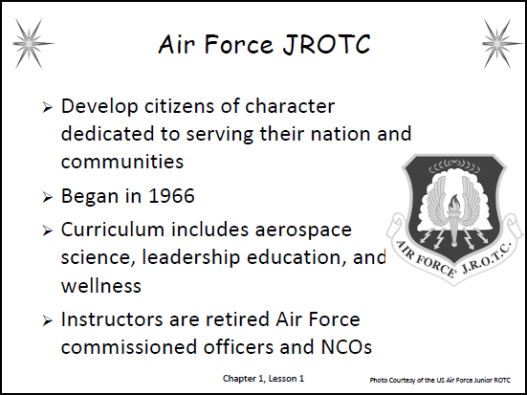Air Force JROTC (AFJROTC)
    1. Mission: To develop citizens of character dedicated to serving their nation and communities
    2. History: The AFJROTC began in 1966 with just 20 units and has since grown to almost 900 units worldwide
    3. Objectives: The objectives of the AFJROTC are to:
       1. Educate and prepare high school cadets in citizenship and life skills
       2. Promote community service
       3. Instill a sense of responsibility
       4. Develop character and self-discipline
    4. Curriculum: The AFJROTC curriculum includes aerospace science, leadership education, and wellness components
    5. Instructors: All AFJROTC instructors are retired Air Force commissioned and noncommissioned officers (NCOs). They serve as full-time employees of the host school
11. 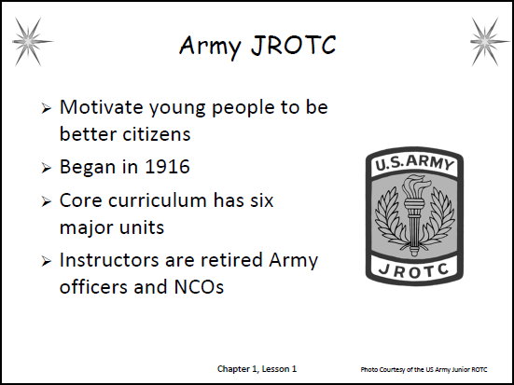Army JROTC (AJROTC)
    1. Mission: To motivate young people to be better citizens
    2. History: The Army JROTC came into being in 1916. AJROTC today has programs in 1,731 schools. Units are in every state in the nation and in American schools overseas
    3. Objectives: The Army JROTC program is designed to:
       1. Promote citizenship
       2. Develop leadership
       3. Develop critical and creative thinking skills
       4. Improve communication skills
       5. Improve health and physical fitness
       6. Strengthen positive self-motivation
       7. Provide a global awareness
       8. Facilitate high school graduation
    4. Curriculum: The AJROTC core curriculum is divided into six major units: citizenship; leadership theory and application; foundation for success; wellness, fitness, and first aid; geography, map skills, and environmental awareness; and civics
    5. Instructors: There are approximately 4,000 instructors in AJROTC classrooms. Two instructors, usually one retired officer and one noncommissioned officer, teach the curriculum
12. 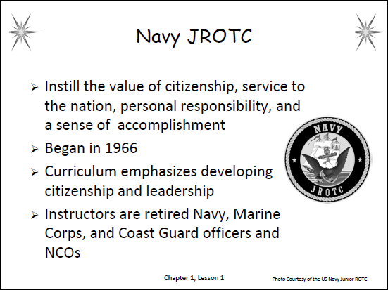Navy JROTC (NJROTC)
    1. Mission: To instill in students the value of citizenship, service to the nation, personal responsibility, and a sense of accomplishment
    2. History: The Navy’s first JROTC programs began in 1966. There are now almost 600 programs nationwide
    3. Objectives: The Navy JROTC seeks to:
       1. Promote patriotism
       2. Develop informed and responsible citizens
       3. Promote habits of orderliness and precision
       4. Develop a high degree of personal honor, self-reliance, individual discipline, and leadership
       5. Promote an understanding of the basic elements of and need for national security
       6. Develop respect for and an understanding of the need for authority in democratic society
       7. Promote community service
       8. Provide incentives to live healthy and drug free
       9. Develop leadership potential
       10. Provide an alternative to destructive behavior and activities, such as gang involvement
       11. Promote high school completion
       12. Promote continuing education
       13. Provide information on the military services as a possible career
    4. Curriculum: NJROTC’s curriculum emphasizes developing citizenship and leadership
    5. Instructors: The almost 1,300 instructors in NJROTC are retired officers and NCOs. They come from the Navy, Marine Corps, and Coast Guard
13. 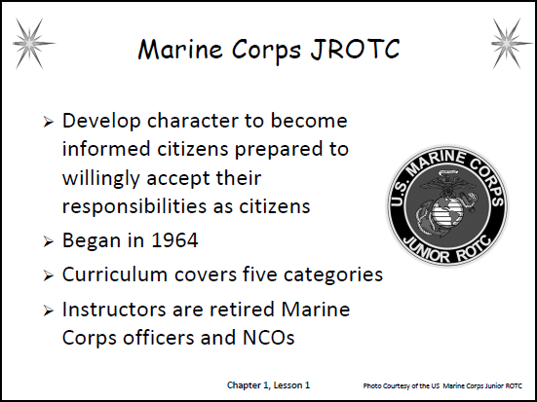Marine Corps JROTC (MCJROTC)
    1. Mission: The MCJROTC Program’s intent is to develop character in high school students—allowing them to become informed citizens prepared to willingly accept their responsibilities as citizens
    2. History: The Marine Corps JROTC program began in 1964 after the ROTC Revitalization Act was signed into law
    3. Objectives: The Marine Corps Junior ROTC program develops:
       1. Informed and responsible citizens
       2. Leadership skills
       3. Strong moral character
    4. Curriculum: The MCJROTC curriculum covers five categories. They include: leadership, citizenship, personal growth, public service and careers, and general military subjects
    5. Instructors: Retired Marine officers serve as Senior Marine Instructors (SMIs). Retired NCOs serve as Marine Instructors. The instructors serve as regular faculty members
14. 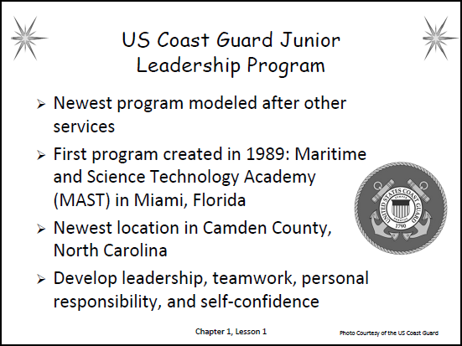US Coast Guard Junior Leadership Program (USCGJLP)
    1. History and Mission: The US Coast Guard is the newest of the programs, and is modeled after those of the other military services; it operates out of two high schools
       1. The first US Coast Guard JLP was created in 1989. It is located at the Maritime and Science Technology Academy (MAST) in Miami, Florida
       2. The newest US Coast Guard JLP unit is in Camden County, North Carolina. It was created in 2010
    2. Objectives and Curriculum: Both programs’ objectives include instruction and experiences that develop leadership, teamwork, personal responsibility, self-confidence, and devotion to school, community, and country

_______________________________________________

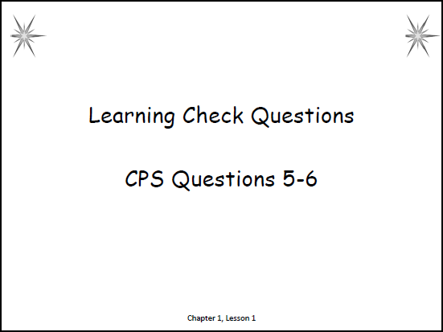**CPS Learning Check Questions (5 – 6)**

*Note to teacher: Ask the following questions using CPS.*

1. Which JROTC program develops cadets’ citizenship, character, leadership traits, and responsibility?
   1. AFJROTC
   2. AJROTC
   3. NJROTC
   4. MCJROTC
   5. **All programs** (p. 7)
2. How many high schools currently have US Coast Guard Junior Leadership Programs?
3. 0
4. **2** (p. 13)
5. 5
6. 10

_______________________________________________

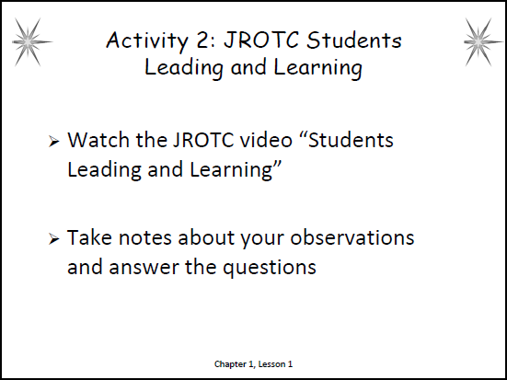**Activity 2: JROTC Students Leading and Learning**

**Instructions for the teacher:**

1. This individual analysis activity enables students to enhance their comprehension of the benefits of the JROTC program.
2. Hand out copies of the student worksheet.
3. Review the directions on the worksheet with students.

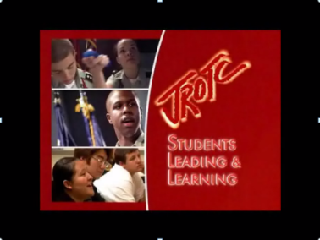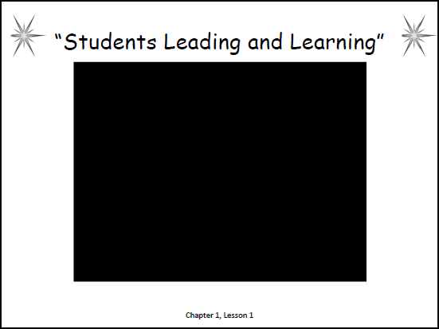*(Note: the video segment is embedded in the slides; an image of the video is displayed in the slide to the right to help you identify the video as it begins playing. When ready, just click on the black video screen to advance the video segment.)*

1. Tell students to be prepared to share their answers with the class.
2. At the end of the activity, use CPS to select two or three students to share their answers.
3. Briefly review the correct answers.

_______________________________________________

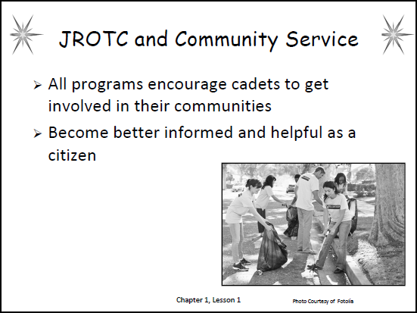

1. JROTC and Community Service
   1. All JROTC programs encourage cadets to get involved in their local communities
   2. As a cadet, you will become better informed and helpful as a citizen

__________________________________________

1. 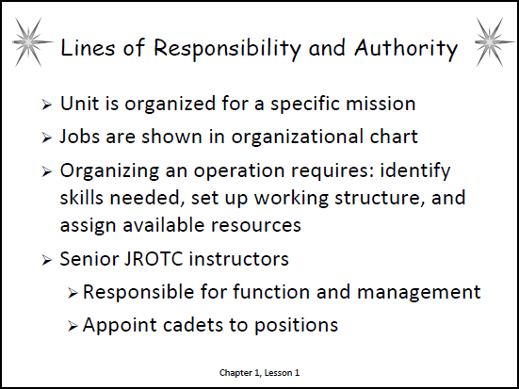**The Lines of Responsibility and Authority in Junior ROTC Programs**
2. An *organization* is two or more people combining their efforts to do a job. Every Junior ROTC unit is organized to carry out its own specific mission
3. The main jobs for individual cadets are normally shown on an *organizational chart*
4. Written job descriptions explain duties in the unit in detail, while the charts provide a quick view of the parts of the unit
5. You should notice that when organizing any operation, it is necessary to do three things:
   1. Identify skills needed
   2. Set up working structure
   3. Assign available resources within the structure to carry out the mission successfully.
6. Organizational Structures and Charts: a JROTC unit’s organization normally reflects that which exists within its parent military service
7. The senior JROTC instructors are responsible for the overall function and management of units. They appoint cadets for the top command and staff positions within their units

________________________________________________

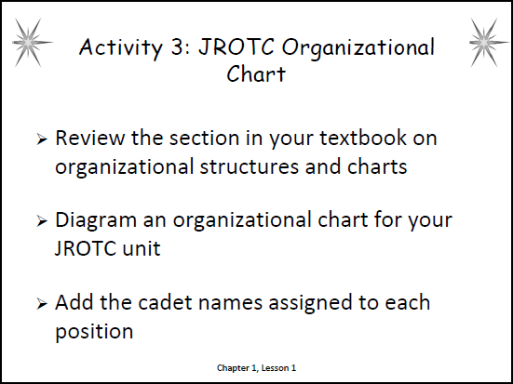**Activity 3: JROTC Organizational Chart**

**Instructions for the teacher:**

1. This partner/small group application activity enables students to organize and summarize the organizational chart for their JROTC unit.
2. Hand out copies of the student worksheet. Divide the class into partners or small groups.
3. Review the directions on the worksheet with students.
4. Tell students to be prepared to share their answers with the class.
5. At the end of the activity, use CPS to select two or three students to share their answers.
6. Refer to the textbook pages 16-19 for your JROTC chart. Briefly review the correct answers.

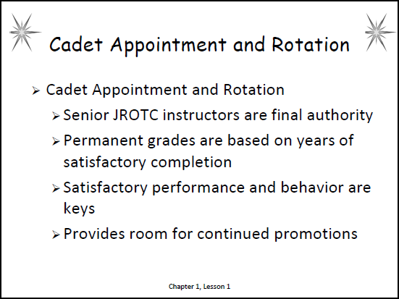_______________________________________________

1. Cadet Appointment and Rotation
   1. Based on how a unit is organized, the senior JROTC instructors are the final authority for appointing cadet corps commanders, subordinate commanders, and staff members, according to the written policy on appointments and rotation
   2. All cadets receive permanent grades based on the number of years they have satisfactorily completed JROTC
   3. Satisfactory performance and behavior are the keys to retaining permanent grades in any cadet corps
   4. The rank structure provides room for continued promotions

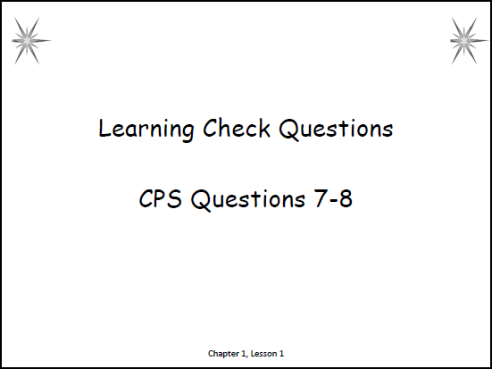______________________________________________

**CPS Learning Check Questions (7 – 8)**

*Note to teacher: Ask the following questions using CPS.*

1. Who is responsible for the overall function and management of units?
2. Cadets
3. Cadet Major
4. **Senior JROTC instructors** (p. 15)
5. Cadet Corps Commanders
6. Who receives permanent grades based on the number of years they have satisfactorily completed in JROTC?
7. First-year cadets
8. Second-year cadets
9. Third-year cadets
10. **All cadets** (p. 20)

______________________________________________

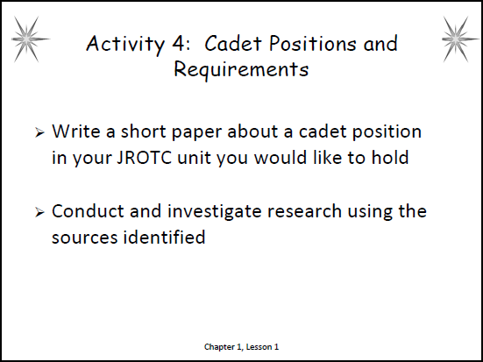**Activity 4: Cadet Positions and Requirements**

**Instructions for the teacher:**

1. This individual technology and research activity enables students to conduct and investigate research and write a short paper on a position in JROTC and the requirements needed to achieve the position.
2. Hand out copies of the student worksheet.
3. Review the directions on the worksheet and the scoring criteria on the Research and Writing Rubric with students; the rubric in located in the Appendix.
4. Allow time for students to conduct the research. Tell students to be prepared to share their findings with the class.
5. At the end of the activity, use CPS to select two or three students to share their findings.

|  |
| --- |
| **PART IIC – WRAP-UP**  Estimated Time: 15 minutes |

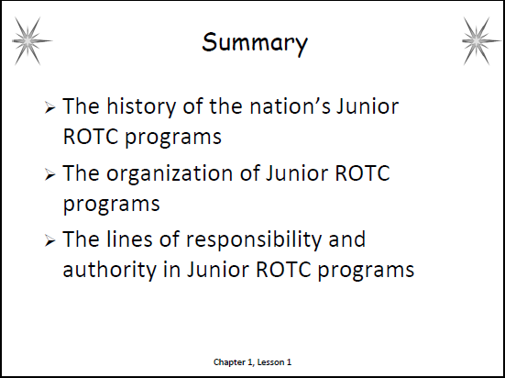**SUMMARY**

In this lesson, we discussed the following:

1. The history of the nation’s Junior ROTC programs
2. The organization of Junior ROTC programs
3. The lines of responsibility and authority in Junior ROTC programs

**CPS Review Questions (9 - 10)**

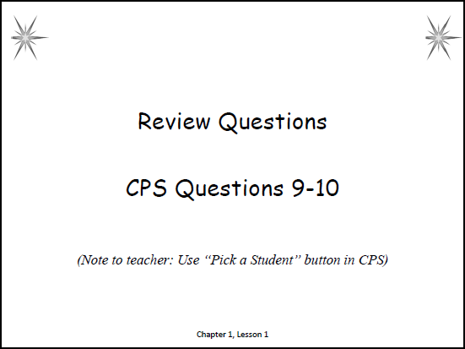*Note to teacher: Have the students write a response on a sheet of paper. Then use the “Pick a Student” button in CPS and select two or three students to share their answers with the class.*

1. Explain your reasons for selecting the JROTC program. What do you hope to gain from the program?
2. What is the most interesting thing you learned in this lesson? Why?

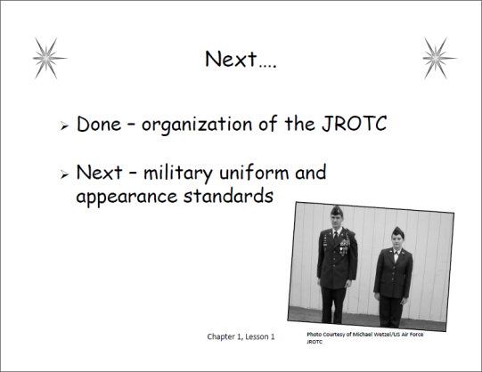

**CLOSURE**

This lesson introduced you to the nation’s JROTC programs. JROTC will help you develop self-discipline and self-confidence. The JROTC program can be a rewarding experience that provides you with skills that will last a lifetime. In the next lesson, you’ll learn about the military uniform and appearance standards.

|  |  |
| --- | --- |
|  |  |

**Checkpoints Answer Key**

Below are the answers to the Checkpoints Lesson Review listed at the end of the lesson in the student textbook edition of *Leadership Education 100: Traditions, Wellness, and Foundations of Citizenship*. They are in the same order as listed in the student textbook and are not assigned in the lesson plans. The answers are provided here in case you want to assign any of them in your classes, for homework, or if your students ask you about them.

1. Who was Lieutenant Edgar R. Steevers, and what did he do?

Army Lieutenant Edgar R. Steevers, the first to organize a JROTC program, believed that military training could help create better citizens. (p. 6)

2. What did the ROTC Vitalization Act of 1964 authorize?

The 1964 ROTC Vitalization Act set the national criteria for schools to begin JROTC programs. (p. 7)

3. What are the four things common to all JROTC programs related to cadets’ development?

All JROTC programs develop cadets’ citizenship, character, leadership traits, and responsibility. (p. 7)

4. Based on your reading, what are three main objectives of your Junior ROTC program? (Note – cadets should answer for their chosen JROTC program.)

Air Force Objectives: The objectives of the AFJROTC are to educate and prepare high school cadets in citizenship and life skills; promote community service; instill a sense of responsibility; and develop character and self-discipline through education and instruction in air and space fundamentals—supporting the Air Force's core values of "Integrity First, Service Before Self, and Excellence In All We Do" (p. 8)

Army Objectives: The AJROTC program is designed to promote citizenship; develop leadership; develop critical and creative thinking skills; improve communications skills; improve health and physical fitness; strengthen positive self-motivation; provide a global awareness, including a historical perspective of military service; and facilitate high school graduation (p. 9)

Navy Objectives: The NJROTC seeks to promote patriotism; develop informed and responsible citizens; promote habits of orderliness and precision; develop a high degree of personal honor, self-reliance, individual discipline, and leadership; promote an understanding of the basic elements of and need for national security; develop respect for and an understanding of the need for authority in a democratic society; promote community service; provide incentives to live healthy and drug free; develop leadership potential; provide an alternative to destructive behavior and activities, such as gang involvement; promote high school completion; promote continuing education; and provide information on the military services as a possible career (pp. 10-11)

Marine Corps Objectives: The Marine Corps Junior ROTC program develops informed and responsible citizens, leadership skills, and strong moral character (p. 12)

US Coast Guard Junior Leadership Program Objectives: develops leadership; teamwork; personal responsibility; self-confidence; and devotion to school, community, and country (p. 13)

5. Who is responsible for the overall function and management of a Junior ROTC unit?

The senior JROTC instructors are responsible for the overall function and management of units. (p. 15)

6. What are three things needed when organizing any JROTC operation?

* Identify skills needed.
* Set up a working structure.
* Assign available resources within the structure to carry out the mission successfully. (p. 15)

7. What are the two keys to retaining permanent grades in any cadet corps?

Satisfactory performance and behavior—as determined by the JROTC instructors—are the keys to retaining permanent grades in any cadet corps. (p. 20)

8. When assigning cadets to positions, what should the instructor staff consider?

When assigning cadets to positions, they consider both strengths and areas for improvement. This helps ensure cadets are assigned to positions where they will gain the most benefits. (p. 20)

Applying Your Learning

9. Describe why cadets who are appointed as Flight Commanders should not hold a rank higher than a Squadron Commander.

A flight commander should never outrank a squadron commander (time-in-grade or promotion line numbers should be used as a management tool when equal grades are involved). (p. 20)

**Activity 1: History of JROTC Timeline**

Name ­­­­­­­­­­­­­­__________________________ Date _______________ Class _________________

**Directions:** Review the section in your textbook on important events in the growth of the Junior ROTC (p. 6). Complete the following timeline by filling in the important events in the growth of the Junior ROTC. Write in years and their corresponding events; use the events listed below. *Note*: The events are not in order. Be prepared to share your answers.

**EVENTS**

* TheUS Army formally adopts JROTC in response to the National Defense Act.
* The Reserve Officer Training Corps Vitalization Act, allows JROTC to be expanded to all branches of the military.
* Norwich, Vermont: First purely technical and military school in the United States for training students in citizen soldiery, named the American Literary, Scientific and Military Academy.
* Leavenworth, Kansas: The first officially established JROTC unit under the National Defense Act is organized at Leavenworth High School.
* Cheyenne, Wyoming: First JROTC program, established as a merger of high school education with noncompulsory military training.

***Start***

**Activity 1: History of JROTC Timeline Answer Key**

**1820:** Norwich, Vermont: First purely technical and military school in the United States for training students in citizen soldiery; named the American Literary, Scientific and Military Academy. (p. 6)

**1911:** Cheyenne, Wyoming: First JROTC program; established as a merger of high school education with noncompulsory military training. (p. 6)

**1916:** TheUS Army formally adopts JROTC in response to the National Defense Act. (p. 6)

**1917:** Leavenworth, Kansas: The first officially established JROTC unit under the National Defense Act is organized at Leavenworth High School. (p. 6)

**1964:** The Reserve Officer Training Corps Vitalization Act, allows JROTC to be expanded to all branches of the military. (p. 6)

**Activity 2: JROTC Students Leading and Learning**

Name ­­­­­­­­­­­­­­__________________________ Date _______________ Class _________________

**Directions:** Watch the JROTC video “Students Leading and Learning.” You will hear about the experiences within the JROTC program from students and parents. Take notes about your observations and answer the questions. Be prepared to share your answers.

**Notes:** _____________________________________________________________________

____________________________________________________________________________

____________________________________________________________________________

____________________________________________________________________________

____________________________________________________________________________

____________________________________________________________________________

____________________________________________________________________________

____________________________________________________________________________

**Video Questions:**

1. How has JROTC helped the students? __________________________________________

____________________________________________________________________________

2. What do the parents think of how JROTC has helped the students? ___________________

____________________________________________________________________________

**Analysis Questions:**

3. Based on what you have observed and experienced so far in JROTC, what do you think are some of the responsibilities of JROTC cadets?

____________________________________________________________________________

____________________________________________________________________________

4. What do you think are some of the benefits for JROTC cadets? ______________________

____________________________________________________________________________

____________________________________________________________________________

**Activity 2: JROTC Students Leading and Learning Answer Key**

1. How has JROTC helped the students? **JROTC helped the students develop self-confidence, enhanced study skills, greater participation, and higher academics/grades**
2. What do the parents think of how JROTC has helped the students? **Parents said the students develop motivation to strive for excellence, ability to focus, and leadership skills**
3. Based on what you have observed and experienced so far in JROTC, what do you think are some of the responsibilities of JROTC cadets? **Student answers will vary**
4. What do you think are some of the benefits for JROTC cadets? **Student answers will vary**

**Activity 3: JROTC Organizational Chart**

Name ­­­­­­­­­­­­­­__________________________ Date _______________ Class _________________

**Directions:** Review the section in your textbook on organizational structures and charts (pp. 15-19). With a partner or small group, use the space below to diagram an organizational chart for your JROTC unit. Add the cadet names assigned to each position. Be prepared to share your answers.

**Activity 4: Cadet Positions and Requirements**

Name ­­­­­­­­­­­­­­__________________________ Date _______________ Class _________________

**Directions:** Write a short paper about a cadet position in your JROTC unit. Specifically identify a position you would like to hold within JROTC and the requirements needed to achieve this position. Conduct and investigate research using your textbook and internet search engine and/or other sources. Write about your findings and cite your sources. Be prepared to share your findings with the class.

**Position:** ___________________________________________________________________

**Sources:**  ___________________________________________________________________

____________________________________________________________________________

**Notes:** _____________________________________________________________________

____________________________________________________________________________

____________________________________________________________________________

____________________________________________________________________________

____________________________________________________________________________

____________________________________________________________________________

____________________________________________________________________________

____________________________________________________________________________

____________________________________________________________________________

____________________________________________________________________________

____________________________________________________________________________

____________________________________________________________________________

____________________________________________________________________________

____________________________________________________________________________

____________________________________________________________________________

____________________________________________________________________________

____________________________________________________________________________