WCSD
Esther Bennett ES
School Performance Plan: A Roadmap to Success

Esther Bennett Elementary School has established its School Performance Plan for the school year. This plan was developed by the school’s continuous improvement (CI) team and informed by a comprehensive needs assessment that included data analysis and meaningful engagement with the school community. It includes the school's goals and process developed during Act 1. The CI team will monitor implementation throughout the school year and evaluate and update the goals at the end of the year.

Principal: Gladis Diaz
School Website: www.washoeschools.net/bennett.
Email: gdiaz@washoeschools.net
Phone: 775-674-4444
School Designations: XTitle I XCSI ☐TSI ☐ TSI/ATSI

Our SPP was last updated on September 1, 2023.

School Continuous Improvement Team
The Continuous Improvement Team is made up of a diverse group of school administrators, teachers, staff, caretakers, and students charged with developing, implementing, and evaluating the school’s continuous improvement efforts outlined in the School Performance Plan.
Name | Role
Gladis Diaz | Principal(s) (required)
Kristy Northon | Other School Administrator(s) (required)
Amy Guevara (ELL)  Nicole Sibillia (Dean)  Hailey Pitts (Counselor)  Michelle Murillo (1st Grade)  Heather Sirotek (2nd Grade)  Elizabeth Avila (3rd Grade)  Brandon Wimbley (4th Grade)  Becky Schmidt (5th Grade) | Teacher(s) (required)
Martha Ramirez (ETS)  Isaac Gomez (FACE Liaison) | Paraprofessional(s) (required)
Matilde Hernandez | Parent(s) (required)
 | Student(s) (required for secondary schools)
 | Tribes/Tribal Orgs (if present in community)
 | Specialized Instructional Support Personnel (if appropriate)
Add additional members/roles as necessary

School Demographics and Performance Information
In compliance with federal and state law, Nevada’s K-12 Accountability Portal provides detailed information about each school’s student and staff demographics and school performance rating, a star-rating system based on the Nevada School Performance Framework (NSPF). You can find our School Rating Report at (Add a link to the school’s School Rating Report.)

School Goals and Improvement Plan
The improvement plan on the following pages articulates our goals for the upcoming school year, strategies we will employ to achieve our goals, and other important planning information.

Inquiry Area 1 - Student Success
Student Success
Areas of Strength | Areas for Growth
ACCESS - This data indicates that there was a 2% increase in the percentage of EL students exited in 2023.  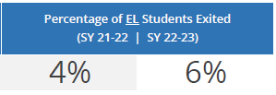  ACCESS – This data indicates that listening is an area of strength for our students.  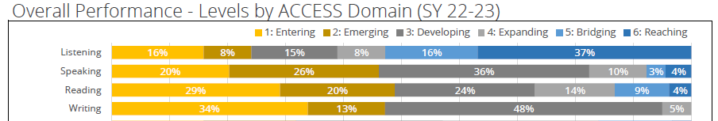  SBAC - This data indicates that in Spring 2023, there was a slight increase in the percentage of students at or above “meets standard” (Level 3) in mathematics.  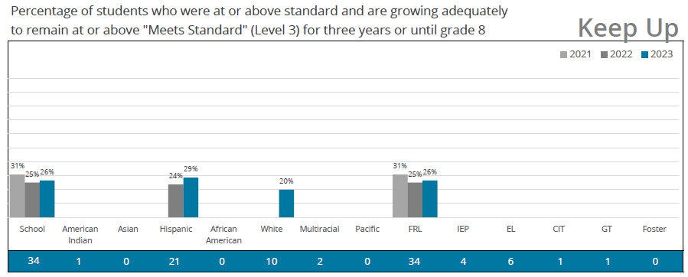 | MAP – This data indicates we have minimal ELA growth between percentile ranges in MAP growth and achievement from Winter 2022 to Winter 2023.  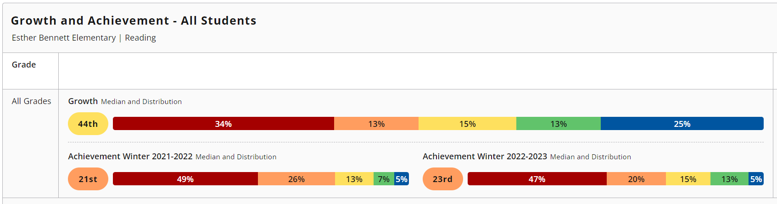  ACCESS – This data indicates we had minimal growth within all ACCESS domains over the last three years.  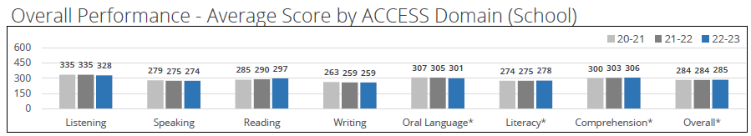  ACCESS – This data indicates a need to provide more support within the speaking, reading, and writing domains.  SBAC –This data indicates a decline in the percentage of students meeting state Catch Up / Keep Up AGP.  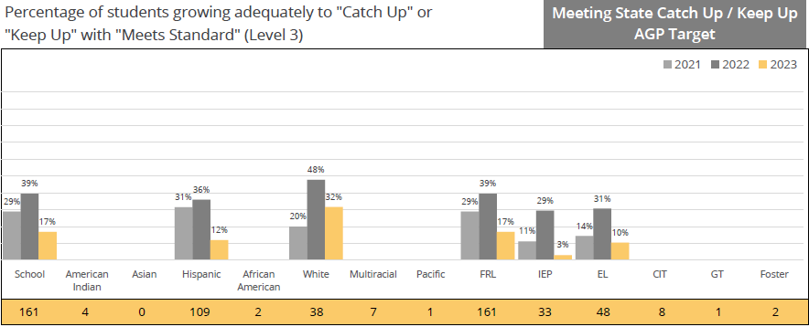
Problem Statement: Most Bennett students exhibit oral language and reading deficiencies and require more support in language acquisition.

Critical Root Causes of the Problem:
As a result of rezoning and new enrollments, we received an additional 150 new students last year. We also had 9 new teachers join our staff last year, and 1 new to a Title I site. Adding these new students and staff members required us to focus heavily on strengthening our school culture and building necessary relationships. We did not have a Learning Facilitator position last year, so we did not have the opportunity to enhance teacher instructional capacity and provide essential support during PLCs. These situations exacerbate existing gaps and inequities amongst our lower SES community and special populations.

Student Success
School Goal: By Spring 2024 ACCESS Assessment, there will be a decrease of 5% in the Entering phase, which will yield an increase in the Emerging, Developing, Expanding, Bridging and Reaching phases. By Spring 2024 i-Ready Diagnostic, 50% of students will have made their typical growth target based on baseline diagnostic assessment data.  Formative Measures:  - ACCESS and i-Ready | Aligned to Nevada’s STIP Goal:  ☐ STIP Goal 1 ☐ STIP Goal 2  ☐ STIP Goal 3 ☐ STIP Goal 4  ☐ STIP Goal 5 ☐ STIP Goal 6

Improvement Strategy: GLAD/ELLevation  Evidence Level: 2/3  Action Steps: What steps do you need to take to implement this improvement strategy?  - Utilize master schedule which allows for grade level common time weekly.  - We will work closely with the EL Department to strengthen our capacity to support classroom teachers.  - Develop and add to the Professional Learning (PL)/Professional Learning Communities (PLC) calendar opportunities for vertical planning time. A specific walkthrough form will be utilized by admin to determine areas of implementation of language strategies, which will also provide areas of need for future professional learning.  - Provide specific professional learning around language acquisition strategies.  - Teachers will continue to meet weekly in PLCs with the Learning Facilitator to collaborate and support one another in their grade level, as well as vertically, to support student academic growth, while accessing and utilizing relevant and appropriate resources (such as Benchmark Advance, Bridges/Envision, Heggerty, i-Ready) for all students.  - The use of school wide sentence frames to enhance student discussion, common language across grade levels to support the development of language acquisition.  - Additionally, embed soft skills through increased implementation and frequency of PBIS and Restorative Practices to support students socially, emotionally, and academically.  - Reteach behavior management and Tier 1 behavior supports.  Resources Needed: What resources do you need to implement this improvement strategy?  - PL and PLC Calendar  - Learning Facilitator  - Time for teachers to meet vertically  - Adopted curriculum, Heggerty, Minute math fact practice for vertically aligned math fluency  Challenges to Tackle: What implementation challenges do you anticipate? What are the potential solutions?  - Implementation Challenge: Balancing adding more training to the calendar and allowing teachers to have more time with their grade levels. Teacher capacity and readiness to implement new concepts shared during professional learning. Providing weekly grade level PLCs even when specials teachers are absent.  - Potential Solution: Learning Facilitator providing differentiated grade level support during PLCs.  Funding: What funding sources can you use to pay for this improvement strategy(ies) associated with this goal?  - Update after Strategy Selection | Lead: Who is responsible for implementing this strategy?  Principal, AP, Dean, Instructional Coach

Resource Equity Supports: Based on your Data Dive and Root Cause Analysis, what if any resource inequities did you identify for the following student groups specific to this goal? (Consider any challenges these groups face.) What, specifically, will you do to support them to overcome these challenges?
English Learners
- Challenge: Increased enrollment of newcomers increases the number of students speaking Spanish.
- Support: Building teacher capacity with language acquisition strategies.
Foster/Homeless:
- Challenge: Meeting the individual social/behavioral needs of students.
- Support: School Social Worker
Free and Reduced Lunch:
- Challenge: N/A
- Support: N/A
Migrant:
- Challenge: N/A
- Support: N/A
Racial/Ethnic Groups:
- Challenge: N/A
- Support: N/A
Students with IEPs:
- Challenge: Making adequate growth on state assessments.
- Support: Students receive Tier 1 instruction in the classroom with intervention/enrichment support. Special education teachers will use Wilson Literacy, Phonics 1st, etc. to support IEP goals.

Inquiry Area 2 - Adult Learning Culture
Adult Learning Culture
Areas of Strength | Areas for Growth
- Staff is very collaborative and willing to work with their grade level team and support staff. | - Looking at various data points to make the best instructional decisions for ALL students and determining how to differentiate for the various instructional needs.
Problem Statement: Teachers need time and support in adjusting to students needs regarding Tier 1 instruction.

Critical Root Causes of the Problem:
- Teachers need support within the Professional Learning Community to make data-based instructional decisions on what else needs to be implemented for individual student growth in addition to the curriculum. We did not have a Learning Facilitator last year to help support teachers with this process.

Adult Learning Culture
School Goal: By May 2024, the percentage of students scoring proficiently on ELA common assessments will grow by 10 percentage points per grade level class average.  Formative Measures:  - Weekly Common Assessments (WCA) | Aligned to Nevada’s STIP Goal:  ☐ STIP Goal 1 ☐ STIP Goal 2  ☐ STIP Goal 3 ☐ STIP Goal 4  ☐ STIP Goal 5 ☐ STIP Goal 6

Improvement Strategy: Teachers will utilize PLC time to develop instruction/lessons to align to and address the Essential Standards in ELA (Tier 1 instructional practices). PLC notetakers will be utilized to help with the backwards planning process (instructional cycle) and housed in Teams so all grade level teachers, support staff, and administration can access.  Evidence Level: Tier 2 – Moderate Evidence  Action Steps: What steps do you need to take to implement this improvement strategy?  - Provide teachers with collaborative planning time weekly.  - Learning Facilitator is present at weekly PLC to provide coaching support as teachers develop plans around Essential Standards.  - PLCs will provide time to unpack the Essential Standards and determine focused vocabulary.  - During PLCs, teachers will engage in data driven discussions with the Learning Facilitator to ensure instructional and assessment alignment to the Essential Standards.  Resources Needed: What resources do you need to implement this improvement strategy?  - Learning Facilitator  - Time for weekly PLCs  - Identified grade level Essential Standards  - PLC notetaker  - Professional Learning time  Challenges to Tackle: What implementation challenges do you anticipate What are the potential solutions?  - Implementation Challenge: Providing weekly grade level PLCs even when specials teachers are absent. Essential Standards to engage in grade level and vertical collaborative work. Time to provide professional learning to all staff.  - Potential Solution: Creating a professional learning calendar.  Funding: What funding sources can you use to pay for this improvement strategy(ies) associated with this goal?  - N/A | Lead: Who is responsible for implementing this strategy?  Principal, AP, Learning Facilitator

Resource Equity Supports: Based on your Data Dive and Root Cause Analysis, what if any resource inequities did you identify for the following student groups specific to this goal? (Consider any challenges these groups face.) What, specifically, will you do to support them to overcome these challenges?
English Learners
- Challenge: N/A
- Support: N/A
Foster/Homeless:
- Challenge: N/A
- Support: N/A
Free and Reduced Lunch:
- Challenge: N/A
- Support: N/A
Migrant:
- Challenge: N/A
- Support: N/A
Racial/Ethnic Groups:
- Challenge: N/A
- Support: N/A
Students with IEPs:
- Challenge: N/A
- Support: N/A

Inquiry Area 3 - Connectedness
Connectedness
Areas of Strength | Areas for Growth
- Increased participation in after school events. | - Continue to build family participation in school events, including family workshops, etc.  - Increase student attendance.  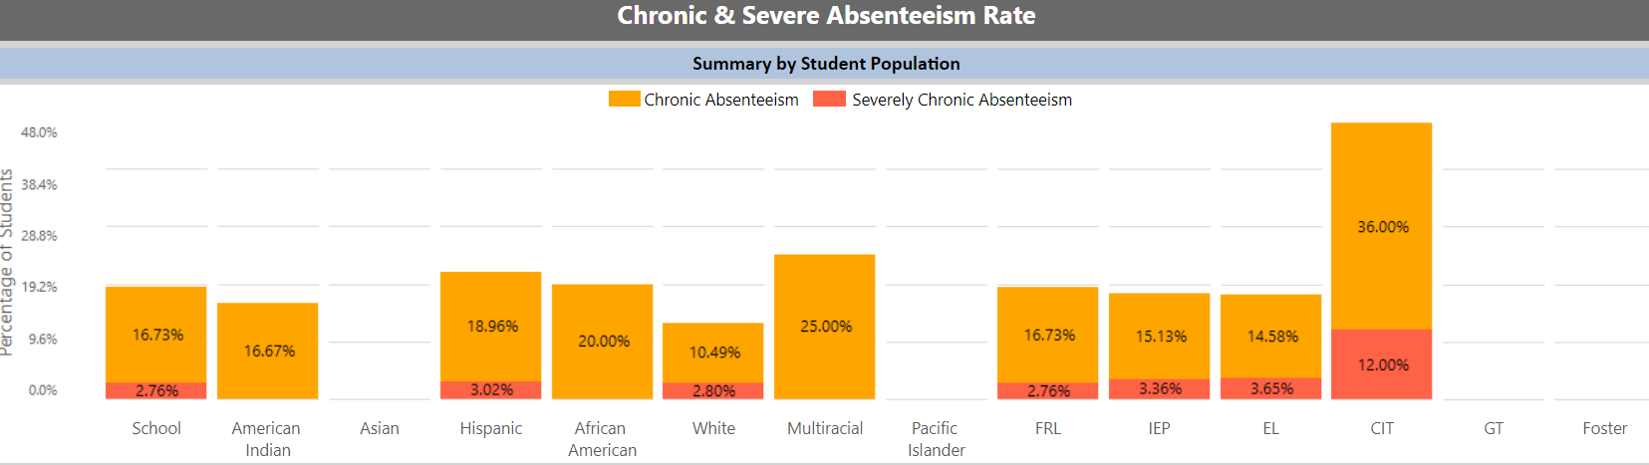
Problem Statement: Parent participation and engagement is an increasing concern with both school events and student attendance.

Critical Root Causes of the Problem:
- Families need to understand the importance of their child’s attendance and the impact it has on their learning. Last year, when it was an off week for transportation, we had an increase in student absences. There are still barriers to families accessing and participating in the school community beyond evening events.

Connectedness
School Goal: By May of 2024, Bennett will increase the attendance at school events by 25%. By May of 2024, we will decrease the chronic absenteeism rate.  Formative Measures:  - Family surveys  - Chronic Absenteeism BIG Report | Aligned to Nevada’s STIP Goal:  ☐ STIP Goal 1 ☐ STIP Goal 2  ☐ STIP Goal 3 ☐ STIP Goal 4  ☐ STIP Goal 5 ☐ STIP Goal 6

Improvement Strategy: Family Engagement with SEL  Evidence Level: Tier 1  Action Steps: What steps do you need to take to implement this improvement strategy?  - Schedule family events (Coffee and Conversations, Parent Workshops, etc.)  - Advertise events using flyers, ClassDojo, ConnectEd, Facebook.  - Weekly meetings to track attendance concerns and utilize the spreadsheet to track attendance concerns followed by personal calls and home visits.  - Meet with Admin team, counselor, social worker, and Dean to track and monitor students’ attendance.  Resources Needed: What resources do you need to implement this improvement strategy?  - FACE Liaison  - Flyers  - Materials pertinent to each event  - Spreadsheet to track attendance  - Social Worker  Challenges to Tackle: What implementation challenges do you anticipate What are the potential solutions?  - Implementation Challenge: Not being provided District interpreter for conferences and other school events. Providing appropriate support for families to decrease student absences.  - Potential Solution: Home visits  Funding: What funding sources can you use to pay for this improvement strategy(ies) associated with this goal?  - Title 1 Funding for FACE Liaison | Lead: Who is responsible for implementing this strategy?  FACE Liaison, Principal, AP, Dean, Counselor, Social Worker

Resource Equity Supports: Based on your Data Dive and Root Cause Analysis, what if any resource inequities did you identify for the following student groups specific to this goal? (Consider any challenges these groups face.) What, specifically, will you do to support them to overcome these challenges?
English Learners
- Challenge: Communicating the importance of parental attendance at events. Communicating the importance of student attendance at school. Language barrier.
- Support: Bennet ES will utilize district and school supports to translate school event fliers and messages (ClassDojo, ConnectEd, Facebook) for parents/guardians for non-native speakers
Foster/Homeless:
- Challenge: Communicating the importance of parental attendance at events. Communicating the importance of student attendance at school. Point of contact, accuracy of contact information.
- Support: Website outreach to reach larger audience, ClassDojo/Facebook as main means of communication, updating IC to reflect changes.
Free and Reduced Lunch:
- Challenge: N/A
- Support: N/A
Migrant:
- Challenge: N/A
- Support: N/A
Racial/Ethnic Groups:
- Challenge: N/A
- Support: N/A
Students with IEPs:
- Challenge: N/a
- Support: N/A

School Community Outreach
This section highlights our school’s deliberate and strategic efforts to engage the broader school community in our continuous improvement efforts by keeping them informed on our progress and learning and eliciting their feedback and perspective.
Outreach Activity | Date | Lessons Learned from the School Community
Open House  Harvest Festival  Parent/Teacher/Student Conferences | August 29  October 26  October 20, 23-26 | - More outreach is needed to increase parent attendance.  - Continue to provide community resources at the Open House.  - Heavily supported and attended by families.  - Continue to host the event outside.

“Resource equity” is the allocation and use of resources – people, time, and money – to create student experiences that enable all children to reach empowering, rigorous learning outcomes, no matter their background. (Definition adapted from USED)

